**Product backlog**

|  |  |
| --- | --- |
| Rank | Product backlog items |
| 1 | As a user, I want to be able to **create a profile** in order to create **comment** on **posts.** |
| 2 | As a user, I want to be able to **view posts** without logging in. |
| 3 | As a user, I want to **track my workouts** in my profile. |
| 4 | As a user, I want to to **view and sing-up for events**. |
| 5 | As a user, I want to make a **request** to an admin to **create an event**. |
| 6 | As a user, I want to **search** for other **members**. |
| 7 | As a user, I want to **send** and **receive** **private messages** with other **members**. |

Each PBI represents a customer-centric feature, usually requiring several tasks to achieve definition of done.





























**Network diagram**

|  |  |  |
| --- | --- | --- |
| **Activity** | **Predecessor** | **Duration (days)** |
| A | / | 3 |
| B | A | 2 |
| C | B | 2 |
| D | A | 2 |
| E | A | 2 |
| F | E,G | 1 |
| G | E | 1 |
| H | E | 3 |
| I | A | 1 |
| J | I | 1 |
| K | J | 3 |

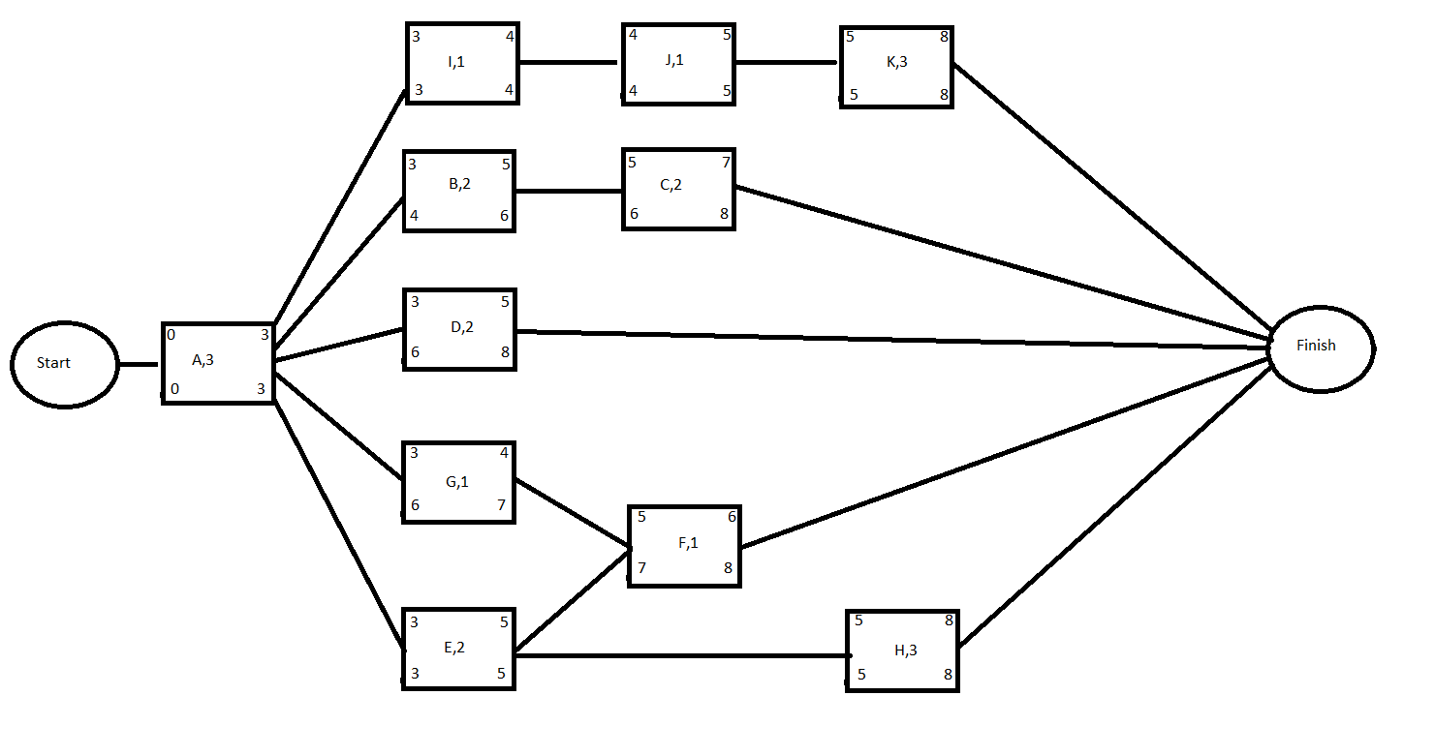

*A,I,J,K* and *A,E,H* are both *critical paths*

*“8 working days”* is the estimation for this project